'''

You are given a set of positive numbers s[].

A variable 'count' stores the count of maximum repeated number/numbers in the set s[].

Your task is to find all continuous subsets of numbers from the given set which should have same 'count' value as original set and print the size of the subset which is minimum.

Input Format:

-------------

Line-1: An integer N represents size of the set s[].

Line-2: N space separated positive integers.

Output Format:

--------------

Print an integer.

Constraints:

1 <= N <= 50000

0<= s[i] <= 49999

Sample Input-1:

---------------

5

3 2 3 4 5

Sample Output-1:

----------------

3

Explanation:

------------

Maximum repeated number is 3 and the count=2.

The continuous subsets with the same count are [3 2 3 4 5],[3 2 3 4], [3 2 3].

the least size is 3 with subset[3 2 3].

Sample Input-2:

---------------

5

5 6 6 7 5

Sample Output-2:

----------------

2

Explanation:

------------

Maximum repeated numbers are 5 and 6 and the count=2.

The continuous subsets with the same count are [5 6 6 7 5],

[5 6 6 7], [6 6 7 5],[5 6 6] [6 6 7] [6 6].

The least size is 2 with subset[6 6].

=== Write your python code below ===

'''

My soln:

n=int(input())

l=input().split()

max=0

for i in l:

if(l.count(i)>max):

max=l.count(i)

k=int(n)

for i in l:

if l.count(i)==max:

begin=l.index(i)

l.reverse()

end=len(l)-l.index(i)-1

l.reverse()

if(end-begin+1<k):

k=end-begin+1

print(k)

**There** are two teams Titans and Warriors with same N number of players.

Both the teams have same set of jersey numbers for their players.

Both the teams stand in two lines opposite to each other from index 0...N-1.

Players from Team-Titans in line-1 and Team-Warriors in line-2.

You have to find an index mapping M[], from Titans to Warriors.

A mapping M[i] = j, means the jersey number of player[i] in Titans team appears

in Warriors team at index j.

The teams Titans and Warriors may contain duplicate jersey numbers.

Your task is to return, lexicographically smallest order.

Input Format:

-------------

Line-1: An integer N, number of players in each team.

Line-2: N space separated integers, T[] jersey numbers of Titans team

Line-3: N space separated integers, W[] jersey numbers of Warriors team

Output Format:

--------------

Print the mapping array.

Sample Input-1:

---------------

6

32 41 51 15 21 10

10 51 41 21 32 15

Sample Output-1:

----------------

4 2 1 5 3 0

Explanation:

------------

Indices -> 0 1 2 3 4 5

Titans -> 32 41 51 15 21 10

Warriors -> 10 51 41 21 32 15

So, the mapping of jersey numnbers is:

M[0]=4, M[1]=2, M[2]=1, M[3]=5, M[4]=3, M[5]=0

Sample Input-2:

---------------

5

10 10 20 20 20

20 10 20 10 20

Sample Output-2:

----------------

1 3 0 2 4

**My soln:**

import java.util.*;

public class Main{

public static void main(String[] args){

Scanner sc=new Scanner(System.in);

int n=sc.nextInt();

int[] titans=new int[n];

int[] warriors=new int[n];

for(int i=0;i<n;i++){

titans[i]=sc.nextInt();

}

for(int i=0;i<n;i++){

warriors[i]=sc.nextInt();

}

int[] arr=new int[n];

Set<Integer> k =new HashSet<>();

for(int i=0;i<n;i++){

arr[i]=search(warriors,n,titans[i],k);

k.add(arr[i]);

}

// System.out.println(k);

// System.out.println(Arrays.toString(arr));

for(int i=0;i<n;i++){

System.out.print(arr[i]+" ");

}

}

public static int search(int[] arr,int n,int num,Set<Integer> k){

for(int i=0;i<n;i++){

if(arr[i]==num && !k.contains(i)){

return i;

}

}

return -1;

}

}

Optimized soln:

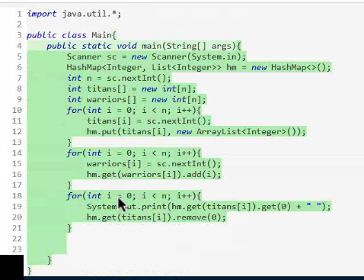

There are two lines of electrical outlets, these outlets support different

voltages range from -100v to 100v. The volatges of the outlets in each line

are arranged in the ascending order using arrays, list1[] and list2[]

Your task is to combine these two lists into one list of outlets, and the

arrangement of outlets should be in the ascending order of their volatges.

INPUT FORMAT:

-------------

Line-1: Two space separated integers, M and N.

Line-2: M space separated integers, voltages of outlets in list-1

Line-3: N space separated integers, voltages of outlets in list-2

OUTPUT FORMAT:

--------------

Space separated integers, voltages of outlets in ascending order.

SAMPLE INPUT-1:

---------------

4 3

1 3 5 7

2 4 6

SAMPLE OUTPUT-1:

----------------

1 2 3 4 5 6 7

SAMPLE INPUT-2:

---------------

2 6

-10 -5

-6 -5 3 4 6 8

SAMPLE OUTPUT-2:

----------------

-10 -6 -5 -5 3 4 6 8

My soln:

import java.util.*;

public class Main{

public static void main(String[] args){

Scanner sc=new Scanner(System.in);

int n1=sc.nextInt();

int n2=sc.nextInt();

int[] arr1=new int[n1];

int[] arr2=new int[n2];

for(int i=0;i<n1;i++){

arr1[i]=sc.nextInt();

}

for(int j=0;j<n2;j++){

arr2[j]=sc.nextInt();

}

int[] arr=new int[n1+n2];

for(int i=0;i<n1;i++){

arr[i]=arr1[i];

}

for(int j=n1;j<n2+n1;j++){

arr[j]=arr2[j-n1];

}

Arrays.sort(arr);

for(int i=0;i<n1+n2;i++){

System.out.print(arr[i]+" ");

}

}

}